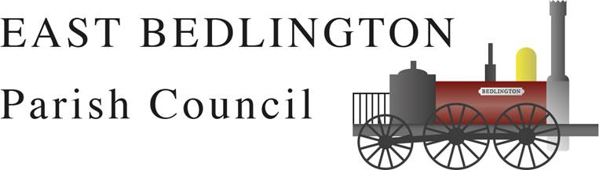

GRANTS AND SMALL DONATIONS FORM

Notes of guidance for Applicants
Introduction
Section 137 of the Local Government Act 1972 empowers local councils to make a Grant to voluntary bodies where, in the Council’s opinion, the grant would benefit any part of its area or any of the inhabitants.
- We cannot fund individuals
- We cannot fund activities or services which do not significantly benefit the residents of East Bedlington Parish.
Who can apply?
- Any organisation can apply provided that:

- It is voluntary and/or non-profit making.

- Can demonstrate the need for financial assistance.

- Operates or lives within the parish of East Bedlington or will give significant benefits to those who reside in the Parish. (Please include the number of beneficiaries in living in East Bedlington and actively participating).

- Operates with no undue restriction to membership.

- Organisations should be able to demonstrate their independence and should have their own management committee and constitution (please include a copy of the constitution with your application).

- Organisations must have a bank account in the name of the organisation with 2 signatories who are not related or co-habiting.

- New organisations can apply providing they are able to demonstrate that they aim to meet the above criteria.

How to apply
- Applications should be made on the enclosed application form.
Jennifer Tindale CILCA
Parish Clerk & Responsible Financial Officer
East Bedlington Parish Council
16 Station Street
Bedlington
NE22 7JN

- Applications should be sent to:

Conditions of Grant
The following conditions will apply to the receipt of a grant
- All applications will be judged on their merits.

- All applications must demonstrate that they need financial assistance and are required to supply full details of what the grant is for, including funding from other sources, estimates and quotations.

- Applicants are advised to obtain a minimum of three quotations, where possible, for goods/services to be purchased and copies are to be attached to the relevant application form.

- Awards must be agreed in advance and will not be made retrospectively.

- There will only be one award per group in (exceptions may be subject to the approval of the Council) each year.

- Where an organisation has applied, grants will not be paid into an individual’s bank account.

- Groups receiving awards above must acknowledge the assistance provided by East Bedlington Parish Council, in all publicity relating to that grant.

- After at least 6 months of receiving the grant, groups must demonstrate how the grant has been spent and publicised (e.g. enclose any copies of receipts, publicity etc).

- East Bedlington Parish Council reserves the right to recover any amounts given and/or moveable equipment purchased if these conditions are not fulfilled, the grant is not used for the purpose specified, or the organisation to which the award has been made ceases to exist.

- The successful applicant also agrees not to dispose of any items purchased with the aid of this grant without written consent of the Parish Council.

- All decisions on grants made by East Bedlington Parish Council are final.

EAST BEDLINGTON
Jennifer Tindale CILCA
Parish Clerk & Responsible Financial Officer
East Bedlington Parish Council
16 Station Street
Bedlington
NE22 7JN
🕿 01670 828808
Or email: clerk@eastbedlingtonparishcouncil.gov.uk
PARISH
COUNCIL

APPLICATION FOR SMALL GRANT

Name of Organisation
Name of Representative
Position in Organisation
Number of Committee Members/Trustees
Address of Organisation
Telephone Number of Organisation
Your Address (if different from above)
Your Telephone Number
Request for Grant
Purpose of grant (please give details of what you want the money for)
*We cannot fund individuals or activities and services which do not provide significant benefit to the residents of East Bedlington Parish.

Amount of Grant Requested

Date Grant Required*
*Please note we cannot provide retrospective funding.
Additional Supporting Information
Have you received grants or applied for support from other bodies?

If so, please specify which funders and the amounts of funding requested, along with the status of your applications. (S = application submitted; A = application agreed; F = funding received; R = rejected).

Declaration

I apply for a grant for the above organisation and declare that:

I, on behalf of …………………………………………….... have read and understood the scheme under which grants are made as contained in the Notes of Guidance.

I, on behalf of ………………………………………………. have noted all conditions under which grants are made and confirm that, if successful in this application, I and the organisation will abide by them.

I am enclosing the most recent balance sheet and statement of accounts of the organisation to whom the application relates or

I am enclosing the last 3 months bank statements (please state reason if not doing so).

I have included a copy of my organisation’s constitution/governing document.

I understand the Council reserves the right to recover any amounts given in the event these conditions are not fulfilled, the grant is not used for the purpose specified, or the organisation ceases to exist.

Signed: ____________________________________ Date ____________________________________
Note: Please ensure you have fulfilled all the above and enclosed the relevant supporting information in your application.

